**#3Ib: A 117 Emergency Communication Platform for Abuse Report in a Mobile Application**

By:

Alonzo, Arlene Grace C.

Belleza, Ram Rainier M.

Dela Cruz, Diane Louise M.

Magat, Mharck Stephen P.

Mañalac, Gerald O.

Pineda, John Carlo C.

Soriano, Justine G.

BSIT 3A

July 26,2021

**INTRODUCTION**

Abuse is a very major concern as it can physically and mentally harm other people. Domestic abuse is regarded as a "widespread social issue". Even before the pandemic, there have been many notable cases of domestic abuses and violence. According to the Philippine Statistics Authority's 2017 National Demographic and Health Survey, one out of every four Filipino women aged 15 to 49 has experienced physical, emotional, or sexual assault from their husband or partner. With the ongoing pandemic, the reported cases have skyrocketed and with this, there have been countermeasures and help became more available.

Quarantine in every aspect helps stop the spread of the COVID-19 virus by staying at home. However, it also increases the susceptibility of violence’s lurking inside our homes. In the Philippines, not only did the pandemic cause health and economic problems, but it also heightened domestic abuse tensions, which likely led to an increase in domestic violence. After a recent Social Weather Stations poll revealed that 1 out of 4 Filipino citizens nationally, or 25%, named violent crimes against women as one of the most important worries of women during the epidemic, the Commission on Population and Development (Popcom) repeated its appeal for their protection. Physical violence was listed as a concern by 11% of Filipinos nationwide, while sexual violence was mentioned by 7% and emotional violence was mentioned by 7%. (Ostuorte, 2021).

As seen on the data gathered by the proponents, an idea has been developed. To further strengthen the services and protection of abuse victims as it increases due to the current pandemic, the proponents decided to propose a study in the field of data analytics. The process of evaluating data sets in order to detect trends and develop conclusions about the information they contain is known as data analytics. Data analytics is increasingly being employed with the help of specialized tools and software (Steadman, 2020). Data analytics combined with technological advancements will bring a faster way of discovering not only the current trends but also the accurate solutions. These solutions will help the society in providing a better environment for the people.

         With this, the proponents intend to propose an application that would be able to solve the escalating rate of domestic abuse and variety of physical, mental, and verbal abuse that is happening in the Philippines. The proponents conducted a pre-survey, based on the results gathered, there is only a thin line difference between the respondents who are aware and not aware of the emergency hotlines. Although there are frequent campaigns about abuse protections and hotlines, many are still unmindful of it.

The proposed study aims to solve the following problems:

* How knowledgeable are the victims regarding the appropriate emergency hotlines?
* How difficult is it for the victim to reach out and report their abuse experience/s or situation to the emergency hotlines and office’s desks?
* What to do when the victim is in that difficult or dangerous situation?
* How to know what are the causes of abuse and who are the accustomed victims or abusers in the area?
* How to file for an initial abuse report of an offender or abuser without actually calling for the authorities?

The idea established from this, pushed the proponents to the proposed study of a report platform in a mobile application that will serve as an easier and faster way to accommodate respondents that need assistance and immediate rescue. It aims to combat the violence happening inside homes, or violence experienced outside by reporting it to the local authorities to exercise their appropriate and legal action as soon as possible. The mobile application will help the victims to report their current or experienced situation through the use of an emergency mobile app that can be a platform for abuse incident reports. In addition, the system will have a communication line, with the legal authority’s office that can dispatch a quick emergency rescue team. Also, a system that would be able to record and hold the data gathered from the complaint reports. With the gathered statistical data reports, the system can display the monthly statistical data status of every governing area, which will help to pinpoint the location/s that are in need of immediate provision of assistance and services.

**Specific Objectives**

* To provide contact information of authorities and offices to report to
* To provide a mobile application that will be able to help the victim to report their difficult situation in an easily accessible way
* To provide a mobile application that helps the victim to know what to do in that difficult situation
* To provide accurate data of cases and deliver comfort services to the victims that will lead to raise awareness regarding the abuse cases
* To provide a system that can raise awareness with the discrete classification of abuse and violence with the help of the gathered data.

With the gathered data:

* Profile of the victim or the complainant

o    Full name

o    Age

o    Relation to the offender

o    Address

o    Contact Information

o    Unoffending Guardian (for minor victims)

* + Gender
  + Type of Abuse
* the authorities will also be able to know the following:

o    Number of victims per area,

o    Number of abusers per area

o    Location with high rate of abuse cases

o    Number of solved cases per area

o    Pending cases per area

o    Cause of Abuse

o    Offenders’ information

* Name
* Age
* Occupation
* Relation to the Victim
* Gender
* Psychological Status/State
* and will be able to use the data as a reference to ignite and provide more help services in the area.

o    Counselling

o    Barangay Protection Order

o    Rehabilitation Support Service

* Women and Children Protection Desk (WCPD)
* Social worker of the Local Government Unit (LGU)
* Department of Social Welfare and Development (DSWD)
* Non-Government Organization (NGO)

         The #3lb: A 117 Emergency Communication Platform for Abuse Report in a Mobile Application intends to provide an easier way to contact the local authorities and social services without being noticed by the abuser. Also, this app will enable them to tell their basic information such as; address or current location, phone number and name, that will be used as proof of record and contact reference. The application can only assess the submitted situation information if there is an internet connection. The age range of respondents will be from thirteen (13) years old and above. The application will only focus on the following features:

a.) Victim’s primary information for initial report,

* + - Full name
    - Age
    - Address
    - Contact Information
    - Date of Incident
    - Brief explanation of the incident

 b.) assessment of the offenders primarily details for initial report

* + - Age
    - Relation to the Victim
    - Gender
    - Condition (Normal State, Drunk, Drugged)

 c.) securing the victim’s details for investigation and rescue assistance or response team.

* + - Full name
    - Age
    - Relation to the offender
    - Address
    - Contact Information
    - Unoffending Guardian (for minor victims)
    - Gender
    - Type of Abuse

 d.) reporting or connecting the application system into the local authority’s office commuline, indicating the filing complaint transaction record.

* + - Women’s help desk
    - Police Station (per Municipality)
    - Barangay Authorities

e.) The call feature of the mobile application is recommended when the victim is unable to proceed for reporting and needs immediate rescuing response or emergency medical aid. The mobile application will redirect the call to the nearest set responders that are registered in the system.

f.) The collected data are only accessible to admin and super admin to follow Republic Act No. 10173, otherwise known as the Data Privacy Act of 2012. Furthermore, the complainant will have an option concerning the collection of his/her personal data by agreeing to the set Terms of Service and Data Privacy Policy Agreement.

The mobile application will benefit the municipal authorities by providing statistical data reports about the rate or number of victims and offenders in the area. The system will inform the authorities by providing the basic information of the victim. Also, the recorded data gathered will be useful as a reference to gain information about the number of violence cases present in the community.

The proposed study will benefit the users by providing a system that would assist them to report the dangerous situation that they experienced. The mobile application will enable them to describe their situation and report it to the authorities. The authorities could be the Barangay Officials or the Police officers in the vicinity.

The study will serve as a platform that will enable victims to seek help and to report offenders. Through the use of the system, it will also be able to project the data of cases that would lead to raise awareness and to lessen the abuse rate and incidents. This could also serve as a reference for other possible development of violence against women emergency communication hotline or awareness.

**Domestic Abuse**

Domestic abuse occurs in homes and with the lockdown, it shows that victims are more likely to have increased risk of the abusers. “Stay-at-home measures including school closures have limited the usual sources of support for families and individuals such as friends, extended family or professionals.” (World Health Organization, 2020). Not all the lockdowns are great for the victims of domestic abuse, since this constrains their movements physically from the help they need that is available outside.

With the ongoing pandemic, it creates a surge of depressive occurrences that is currently happening to people. “The social isolation required by the measures taken in the different countries, the impact on jobs, the economic instability, high levels of tension and fear of the virus, and new forms of relationships have all increased levels of stress in the most vulnerable families and, therefore, the risk of violence.” (Pereda & Díaz-Faes, 2020). Moreover, the risk of being infected with the COVID-19 is still ever-present, leading to a potential high case of being infected.

**Online Platform**

Right now, there are ways to continue the learning through the online internet, however children are one of the most vulnerable to abuse even in cyberspaces. “Additionally, more time online may expose children to an increased risk of online sexual exploitation or bullying.” (Kuehn, 2020). This shows that the internet can still be one of the ways to exploit and abuse children.

There also exists cases where abusers in the pre-pandemic do continually violate their companions in their relationships. According to Campbell, J. (2020), “If domestic abuse is already a problem in a relationship, the coronavirus pandemic might be making it worse.” Meaning that pre-existing conditions and circumstances in the affair can greatly affect it.

**COVID 19 Pandemic**

Abusers and victims of abuse have been around more than the pandemic. “No less than the battle against the COVID pandemic, the battle against the abuse pandemic is certain to be an ongoing one.” (Klugger, 2021). The ongoing pandemic brought more implications to society, concluding that the viral infection is not only just the worst-case scenario.

Along with the one after another losses of individuals due to the pandemic, their anxiety heightens. “Stress has also been a big factor during the pandemic and is often brought about by the loss of a job and health fears.” (Calleja, 2020). The assurance of every individual's prosperity plummets as the spread of the COVID-19 virus.

Mental wellbeing is also one of the major health aspects to look out for. “For survivors of gender-based violence locked down in their homes with an abuser, the COVID-19 pandemic is only one of the compounding crises that threaten their physical and mental health.” (Gonzalez, 2020). These impacts of abuse can inflict psychological trauma, influencing the victims’ mental health.

With protocols and mandated rules to follow, more and more people are staying at home. However, this also restrains activities and authoritative actions that may be helpful to the potential abused victims. “Due to restrictions on movement, it’s more difficult for people to escape and easier for loved ones to miss the signs that something is wrong.” (Wallace, 2020). Along with the victim’s continual deterioration of their health, they cannot seek help themselves alone.

According to the post on the website of Makati Medical Center (2020), “The limited movement allowed during quarantine makes it difficult for them to call for help.” This implies that in the lockdown periods, abusers can maltreat more of their victims than the pre-pandemic times. Having active social help that is promoted by certain individuals and authorities is also one way to combat domestic violence.

         Even without the lockdown or the pandemic, help was not readily accessible to them. “And when the pandemic is over, victims of domestic violence and their children will continue to need help.” (Richards & Nix, 2021). With the rising cases, this cannot go unnoticed to the public as time goes by.

**Android Application**

Based on the study, the application of the Theory of Planned Behaviour in the research conducted by the proponents of the World Conference on Gender Studies in Malaysia is effective in determining the factors of reporting of child abuse cases. The aforementioned theory explained that it showed crucial points and information about human behavior through the level of beliefs and assumptions. These findings from the results can pinpoint the problems in intervention of child abuse cases or change existing policies that can help the authorities carry out duties more effectively.

On a function in the android application Abhaya, an android application for the safety of women, it uses Global Positioning System to track users and send their location to the application. Furthermore, it also contacts their immediate registered person in their contact numbers that alerts them and sends their location using a Google Map link every five minutes. The user can provide four available contacts in the app namely a Police Officer, their families and loved ones.

Visual Information Reporting is also regarded as one of the main features in the app Relayvio that documents domestic violence. Photos from the aftermath of the abuse is seen here as it shows the physical damage dealt by the abuser by providing a picture of the users’ wounds and injuries. This app is useful in documenting abuse as it captures the images, date, and notes that can help to inform the authorities, friends, and families.

**Risk Assessment Application**

One of the most commonly used in assessing risk is the Danger Assessment found in the Mobile Application for Survivors of Domestic Violence. It contains two parts, the calendar part and the instrument part. The calendar part can mark dates where abusive events are rated one to five based on the severity of aggressions. The instrumental part contains twenty items to answer and its result can predict the power of violence that occurred to the victim.

Having and creating an Awareness Module found in the application iJuanaHelpMo educates victims that can help to know their own rights, what resources they can find, and support that is applicable to any Filipinos regarding violence and abuse they experience inside their homes. In this application module, victims can read related laws and rights related to Violence Against Women and Children. They can educate themselves as it serves a series of references that is linked to their current state.

Due to lack of web-based systems or mobile applications, Malaysia previously does not have a means of handling out of available assistance to their potential domestic violence victims. Also, lack of manpower, funds, and resources of Non-Government Organization is also one of the primary causes of this. However, with the cases rising, there are applications that started to launch to combat domestic violence but the application TINA (Think I Need Aid) provides additional features that can encourage users emotionally and psychologically by their numerous functions of the app. An example of this is the users participating in a domestic survivor group chat in WhatsApp and a free counselling with the Women's Aid Organization, a local non-governmental organization in Malaysia.

**Crime Report Application**

         As with the rise of android mobile smartphones, its popularity and simplistic design became prominent to people as it has numerous functions and its portability. Therefore, with this wide range of potential available users, in a certain function of We Safe App, a user can notify all users of the app to find missing persons. With their general appearance information and photograph provided by the user, other users will be notified through the app. This process of functionality can be used by the police to track down people who are potential criminals provided in their wanted list.

         Users can add their friends and families into the contact information to the system as introduced in the Interactive Internet of Things for real time Crime Reporting as who they seem fit. In this way, the app alerts them first of the unexpected crime as the user sends alarms and current information about them. The individuals who were registered as immediate contacts can act swiftly as the app alerts them.

         Furthermore, the contact system that alerts first their close relatives and friends is also seen at the study, Eyes and Apps on the Streets: From Surveillance to Sousveillance using Smartphones. According to the author, this is done to enhance the safety of the user. It also has an adding image function when users add an event in the app to provide possible evidence. This functionality can make documenting of abuses easier.

In a study from A Cloud-Based Crime Reporting System with Identity Protection, the informer uses an integrated circuit card or smart card to report an event even without his/her identity. The smart card will verify the identity of the reporter and can be used to log in the system without their identities being shown. Without compromising the reporter's identity information, their statements would hold more information and can provide more definite testament.

         The proponents looked at similar research on the internet and identified additional elements that may be included in the suggested system. The proponents have been noticing the rising cases of domestic abuses happening in the Philippines alone appearing in the local news. Also, as seen from the related studies and literature domestic abuse is still happening and is increasing because of the pandemic.  Due to the rise of the coronavirus pandemic, the help and the aids the victims normally get from these cases becomes more slow-acting due to the strict implementations of social distancing and the stay-at-home order.

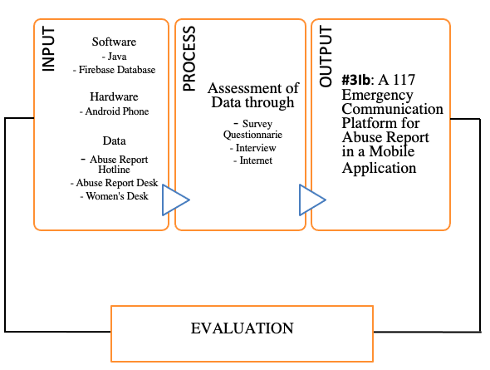

*Figure 1. Conceptual Framework*

A conceptual framework explains why a certain study should be carried out. The conceptual framework establishes the methodological underpinnings of the research endeavor and describes the state of known information (Varpio et al., 2020). The conceptual framework is made up of input-process-output. The proposed system's Conceptual Framework will demonstrate how the study will be conceived and realized.

As stated in the diagram above shown by the proponents, the inputs are as follows; Software, hardware and Data. The software that will be used to develop the application are Java, Firebase (Realtime Database) and Android Studio. The hardware that will be used are Android Phone and Laptop. The Data that will be used to provide information to the application came from the information gathered from the interview of police officers and website. In the process phase, the system will process the data gathered from pre-survey questionnaires, interviews and related studies from the internet. With the help of the inputs and processes the mobile application will be developed. The proponents and end users will test the system to see if it works properly, and if bugs or errors are discovered, the developers will troubleshoot the issue, and once it has been resolved, the developers will test the system again to see if there are any remaining issues or if the system is working properly.

**METHODOLOGY**

Methodology is a set of procedures or techniques for locating, selecting, processing, and analyzing information about a subject. The methodology portion of a research article allows the reader to critically examine the study's overall validity and dependability (Leedy, 2021). This section will answer the questions such as how will the proponents gather the necessary data and analyze it. The proponents will discuss the research design, research instruments and the standards that will be used to analyze the data that will be collected.

The proponents will use a quantitative descriptive type of research design because the purpose of the proposed study is to serve as a helpful way of reporting abuse cases through a mobile application and also to gather data regarding the abuse cases in the target locale. Quantitative research involves collecting numerical data and analyzing it mathematically to understand phenomena. Quantitative research is further distinguished by the use of instruments such as questionnaires, interviews, and computers. Descriptive research is described as a research method that aims to accurately characterize existent occurrences. The term "existing phenomena '' distinguishes descriptive research from experiment research, which examines not only existing phenomena but also phenomena following a time of treatment (Atmowardoyo, 2018). Descriptive study designs are helpful for describing the desirable characteristics of the sample under investigation (Omair, A., 2015).

System development life cycle (SDLC) is a project management concept that describes the stages of an information system development project, from the first feasibility study to the ongoing maintenance of the finished product (Gillis, 2019). SDLC assists in the transformation of a concept into a fully functional and operating system. The proponents will use agile methodology for software development of the application. The agile model emphasizes the collaboration of the group, user feedback, continuous improvement, and the capacity to adapt to changing activity. The stages of the methodology that the proponents used are initial planning, planning, requirements, analysis and design, development and testing, and evaluation.

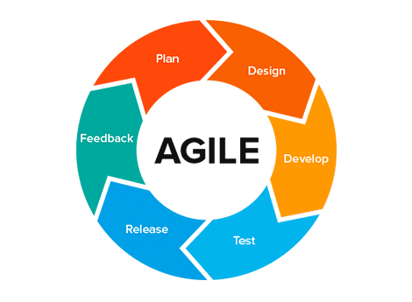

*Figure 2 Agile Systems Methodology (Abellán, 2020)*

**Initial Planning**

The proponents will collect data from different related literature, studies, and existing applications related to crime about abuse. The PNP Women’s Desk and officials from Local Government Units (LGUs) were interviewed as part of the study. The researcher will be able to better understand the demands of the application's users and some of the victims who have been reported with the support of official government input. Browsing the materials for the mobile application's development will also be done.

**Planning**

The proponents will evaluate the collected information in order to create all of the possible plans and objectives, as well as the application's concept and target clients. Examine the present mobile application's features to determine its capabilities.

**Requirements**

In order to complete all of the study's requirements. The proponents will begin organizing the data with the use of some hardware such as personal computers and various software in order to construct and analyze the study.

**Analysis and Design**

Using different methods such as Data Flow Diagram (DFD) and Entity-Relationship Diagram (ERD), the proponents will design and conceptualize the layout and techniques of the mobile application in this phase. The flow of the #31b mobile application was analyzed using DFD and ERD based on its function.

**Development and Testing**

The proponents will begin developing the application at this point, based on the ideas generated during the analysis and design, as well as the data acquired and the needs. The testing stage of the mobile application will verify if the mobile application is functioning properly and if it contains any possible errors or bugs. A variety of tests will be carried out to confirm that all relevant features are present.

**Evaluation**

Using ISO/IEC 25010 and Likert Scale to determine the level of acceptance and usability of the #31b mobile application. Following the evaluation, the proponents will devise a strategy for improving and maintaining the mobile application in accordance with the findings.

The research instrument will be in the form of a survey questionnaire. The survey questionnaires contain questions, this questionnaire will help the proponents to determine and prove that the problem statement is correct. The method of doing research through surveys that proponents send to survey respondents is known as survey research. Survey data is then statistically examined in order to draw significant study results ("Survey research: Definition, examples and methods | QuestionPro," 2021). One of the most effective research methodologies has been demonstrated to be surveys. Survey assists in gathering essential information from a huge number of people, allowing you to reach a valid and objective judgment (Blog, 2020).

The proponents will use random sampling design to determine the sample population within Pampanga. A sampling strategy in which each sample has an equal chance of being chosen is known as random sampling. A sample drawn at random is supposed to be a fair reflection of the entire population ("What is random sampling? Definition of random sampling, random sampling meaning," 2021) . According to the 2015 Census, Pampanga has a population of 2,198,110 people ("Pampanga," n.d.). The researcher used Qualtrics website to determine the sample population which resulted in three hundred eighty-five (385). Cluster sampling design is a probability sampling technique in which all elements of a population are classified into mutually exclusive and exhaustive groupings known as clusters (Frey, 2018) . The Pampanga is divided into four (4) districts, the proponents will randomly select one (1) district and it will be the selected sample population for the study. 385 respondents will be equally divided into the six (6) municipalities that are under the selected district which is the 2nd Congressional District of Pampanga.

The municipalities located in the 2nd Congressional District are; Floridablanca, Guagua, Lubao, Porac, Santa Rita, and Sasmuan. It has a total of 672,645 residents, taking up the 3.26% total population of Pampanga (Philippine Statistics Author (PSA), 2015) with 159 barangays (Philippine Standard Geographic Code (PSGC), 2021).

The characteristics of the respondents are as follows; thirteen (13) years old and above, residing in the said municipalities, victims of abuse, witnesses of abuse, male, female or LGBTQ+. Only current living residents of Second district will be included. Any non-resident respondent will be excluded. Ages twelve (12) years old and below are considered as volatile participants and will not be taken into consideration for the study.

The proponents will use Likert Scale to analyze the statistical data from the survey questionnaires and the evaluation tool. A likert scale is a psychometric response scale that is commonly used in surveys to determine a participant's preferences or level of agreement with a statement or collection of statements. Likert scales are a type of noncomparative scaling technique that measures only one trait. Respondents are asked to use an ordinal scale to indicate their level of agreement with a specific proposition (Bertram, 2017). The gathered data will then be analyzed using the weighted mean and be interpreted. The verbal interpretation that will be used to interpret the weighted mean are the following: (1) 1.00-1.80: Needs Improvement; (2) 1.81-2.60: Fair; (3) 2.61-3.40: Good; (4) 3.41-4.20: Very Good; (5) 4.21-5.00: Excellent.

The system will be evaluated using the software quality standard called International Organization for Standardization (ISO) / International Electrotechnical Commission (IEC) 25010 for the evaluation of the system. The proponents will follow the standard of ISO/IEC 25010 to categorize the mobile application functionalities. The ISO/IEC 25010 categorization of software quality requirements are follows: functional stability - to know what the mobile application does, performance efficiency - to know if the mobile application uses an optimal amount of resources, compatibility - to know if the mobile application can work cross-platform, usability - to know if the specific user can use the mobile application in specific condition, reliability- to know if the mobile application is stable enough to cater the needs of the user, security - to know if the mobile application can protect information and data, maintainability -  to know if the mobile application can be possible to be modified or improved in the future or will it adapt to changes of the environment, and  portability -  to know if the mobile application can be used in various environments. (Rebes, 2019)

The proposed system will benefit the users by providing a mobile application named #31b Emergency App, that would assist them to report the dangerous situation that they experienced. The said mobile application will enable them to describe their situation and report it to the authorities. In case of emergency, the nearest local authorities will respond immediately. The mobile application also displays information about other services offered by the municipal sector centered on abuse. Other services such as victim counselling, protection orders, shelter and support. These services will help the victims to regain and improve their welfare.

One of the business processes that the proponents and the clients require is a management process which governs the system of operation of the client’s organization. These are case reporting and emergency response. Next, the supporting processes such as office personnel are put in place. The user’s requirement is to have an account that will be used in the mobile application and also a valid mobile number for the verification of details.  For the #31b Emergency App to be tested and give the proponents a chance to evaluate the said proposed system.

**Visual Table of Content**

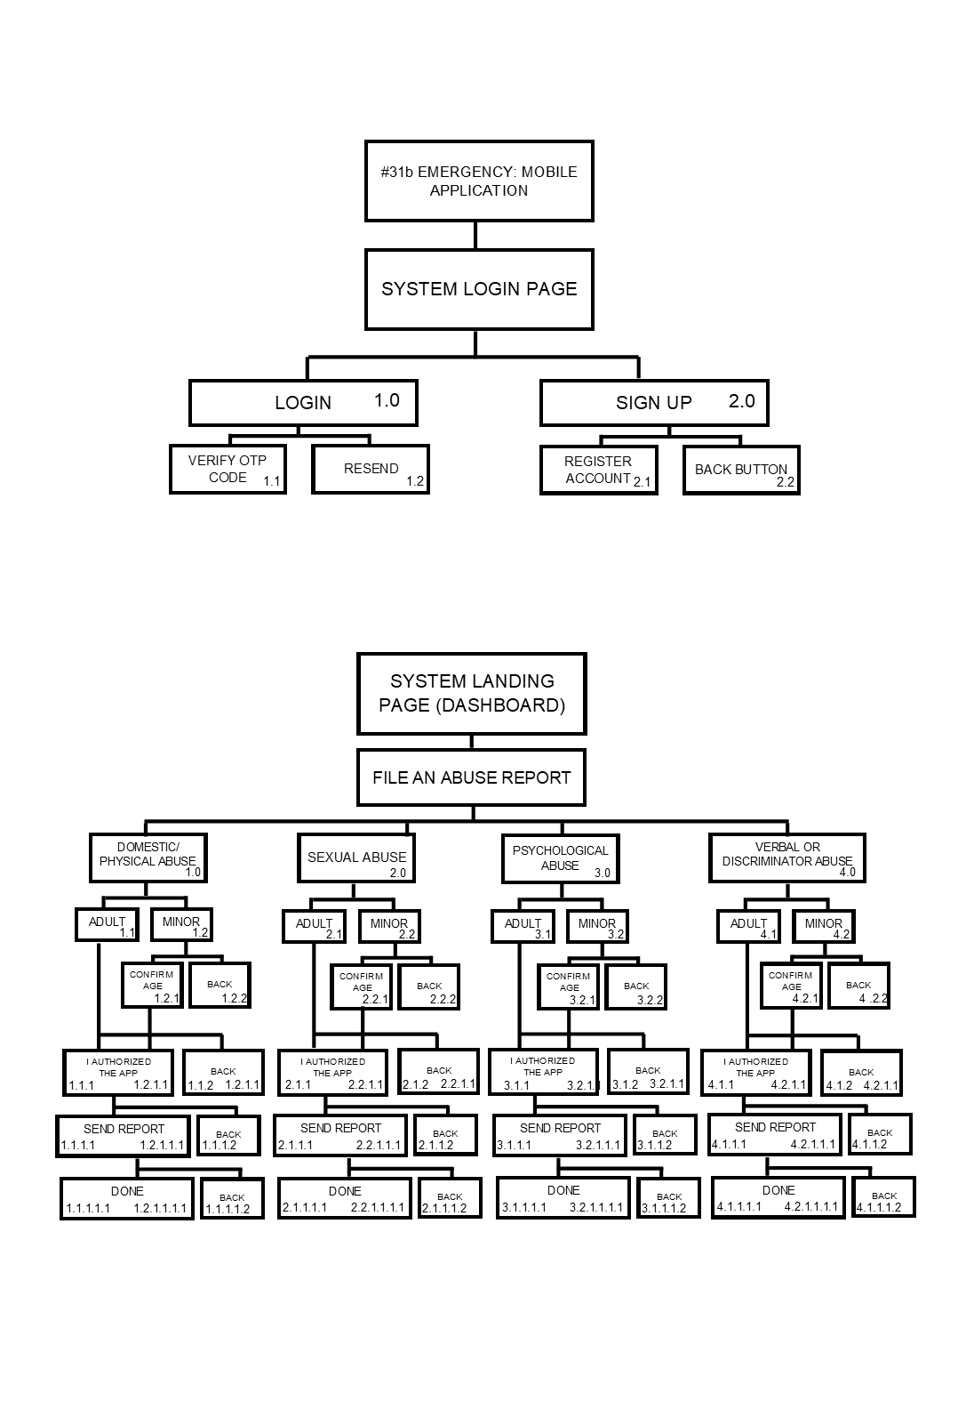

*Figure 3 Visual Table of Content of Proposed Study*

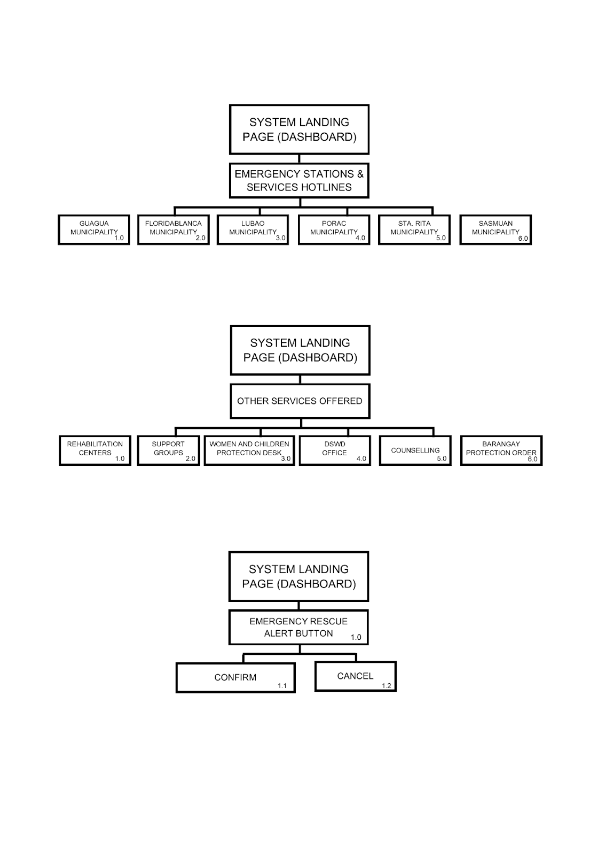

*Figure 4 Visual Table of Contents of Proposed System*

**Data Flow Diagram Level 0**

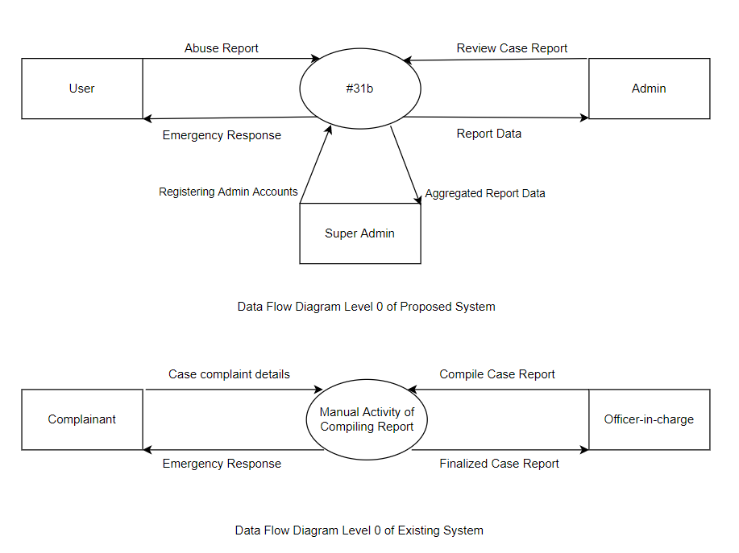

*Figure 5 Data Flow Diagram Level 0 of Proposed System*



*Figure 6 Data Flow Diagram Level 0 of Existing System*

**Context Diagram**

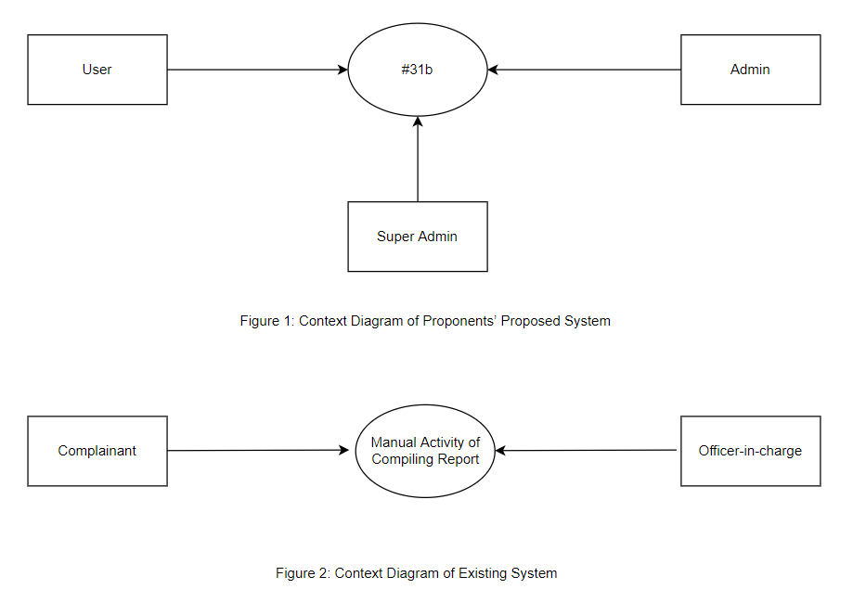

*Figure 7 Context Diagram of the Proposed System*



*Figure 8 Context Diagram of the Existing System*

**Entity Relationship Diagram (ERD)**

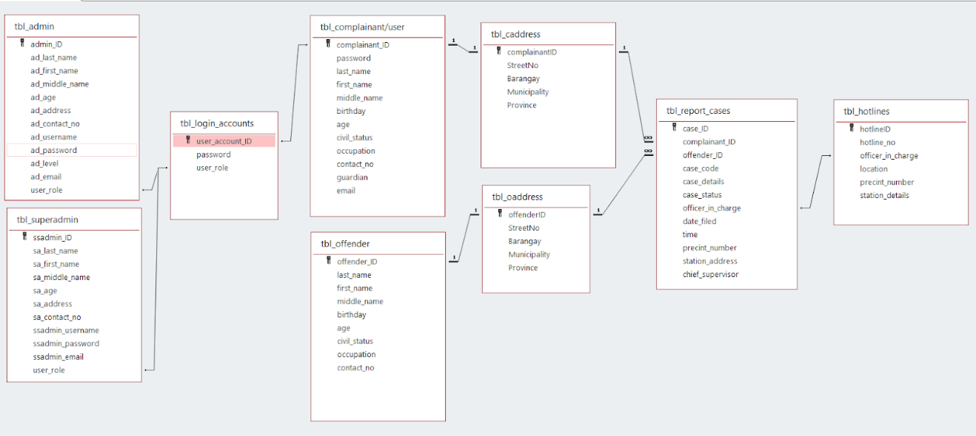

*Figure 9 Entity Relationship Diagram of the Proposed System*

**System Flowchart**

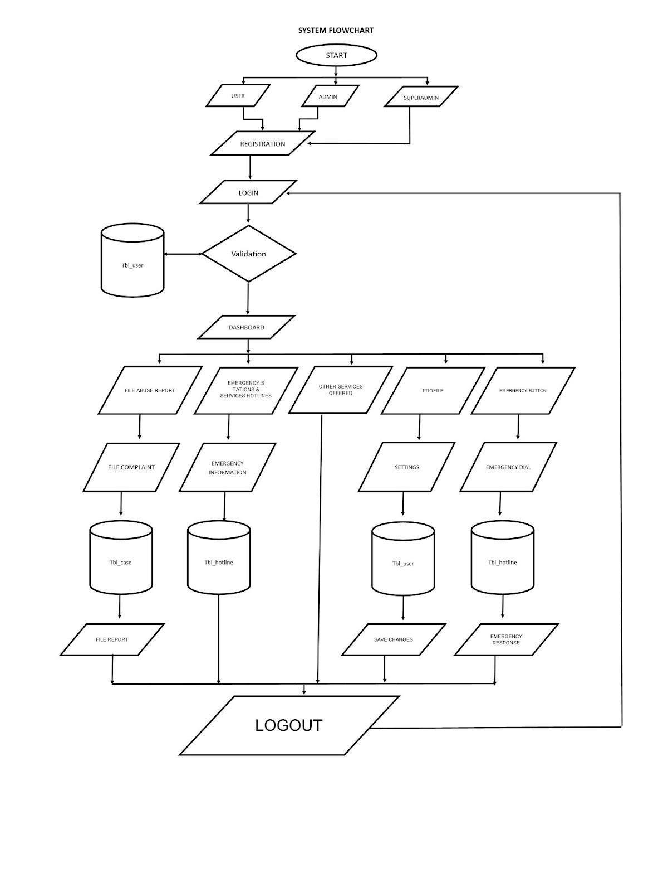

*Figure 10 System Flowchart of the Proposed System*

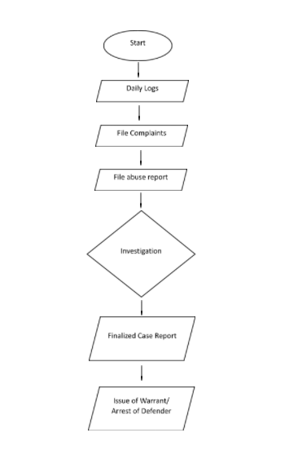

*Figure 11 System Flowchart of the Existing System*

**Program Flowchart**

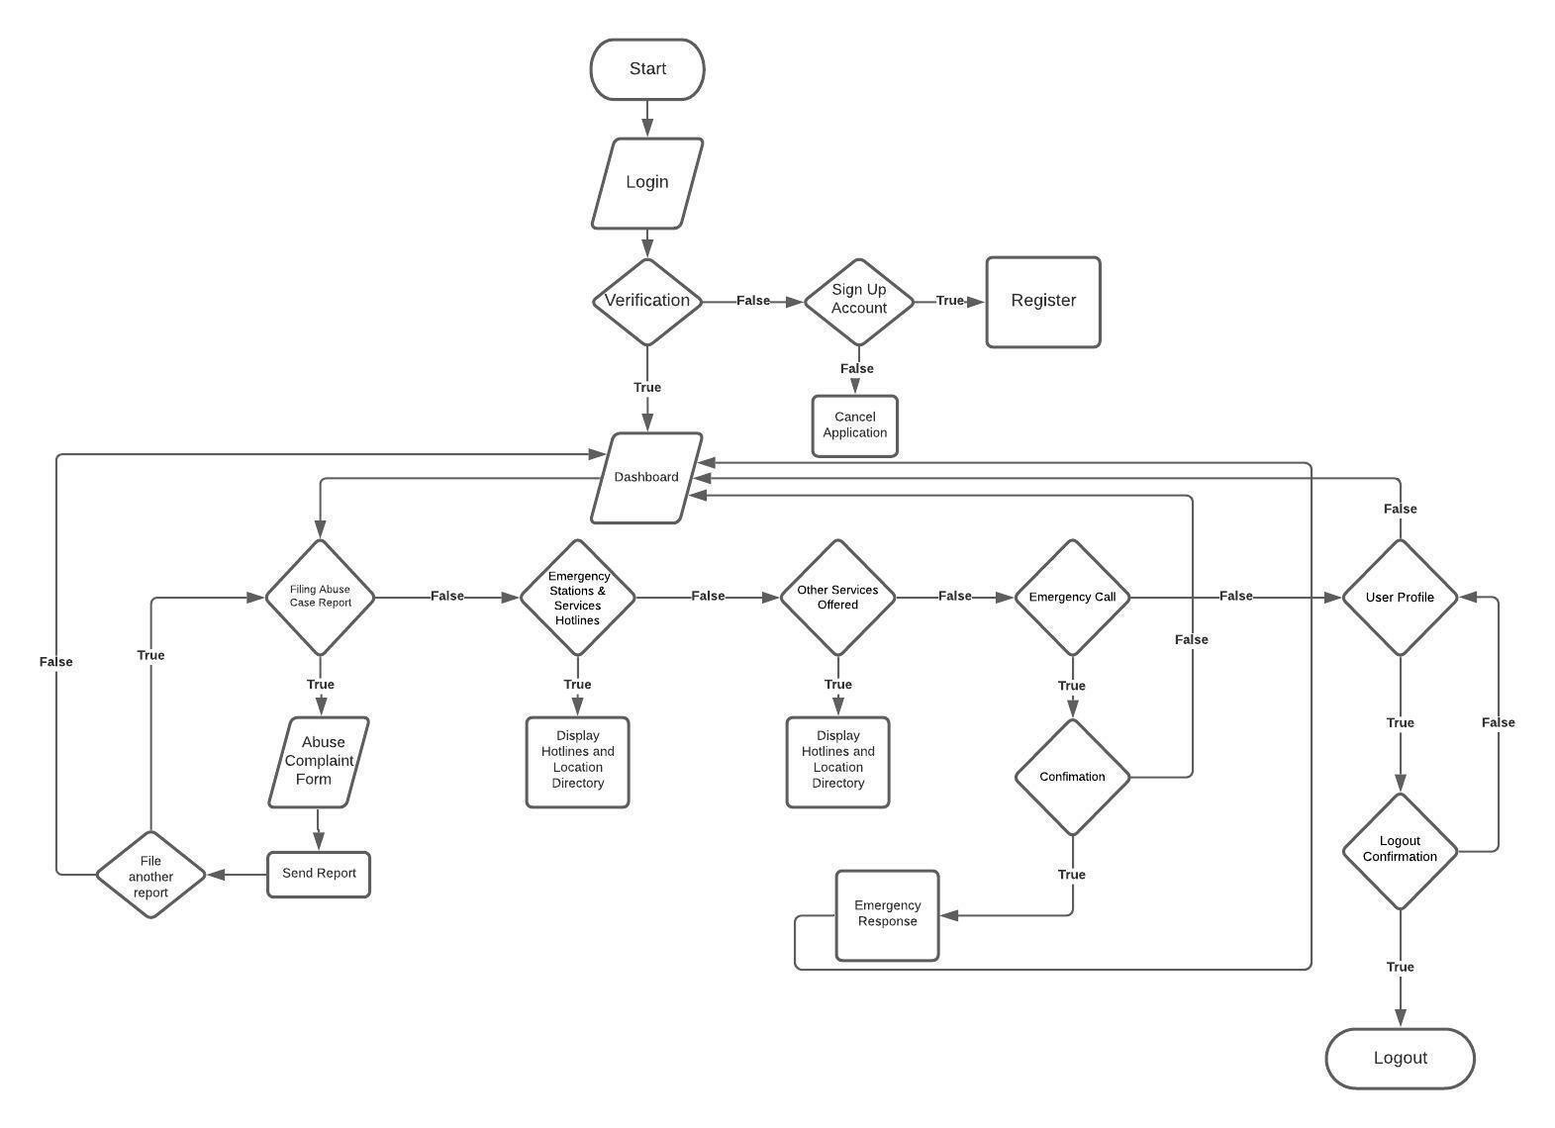

*Figure 12 Program Flowchart of the Proposed System*

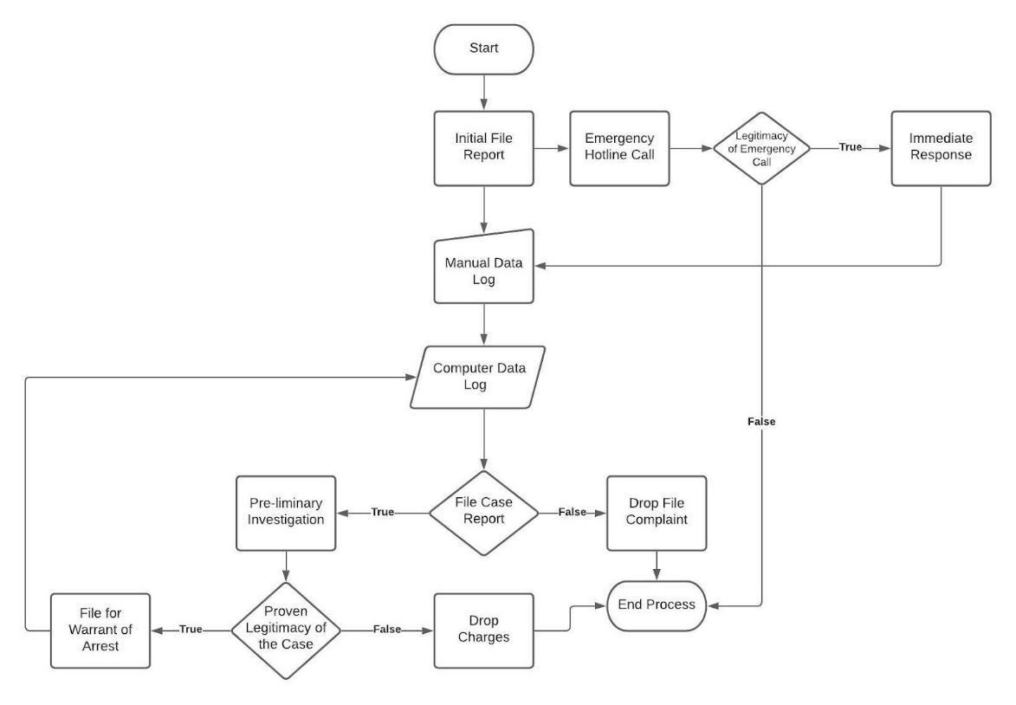

*Figure 13 Program Flowchart of the Existing System*

The proponents analyzed similar studies found on the internet and noted more usable features that can be implemented in the proposed system. Therefore, the proponents came up with the idea that a handheld device is best suited for the reporting of abuse. The Android operating system found in these types of devices is more commonly used and most suitable to create customized applications to create appropriate responses suited for different needs of the user.

Data flow diagrams were created by the proponents to illustrate a graphical representation of data flow via an information system and to define how the system would look and work. The Data Flow Diagram (DFD) depicts the flow of data through an information system, but it does not depict program logic or processing stages. A series of DFDs creates a logical model that demonstrates what and how the system works. As seen in Figure 4, the entities involved in the data flow diagram are the user, super admin, admin, and the system. The super admin and the admin will be the ones who will manage and maintain the system, while the user is the one who will be using the system and is the source of data that will be managed by the system and the administrators. The system is the output that will manage the data and will be monitored by the administrators. The processes were also seen in the figure, as the user inputs data into the system, the system will then process the data and produce an organized information that will be sent into the database and will be monitored by the administrators.

The proponents used an Entity Relationship Diagram to show the relationship between each table in the database. An entity-relationship diagram (ERD) is a sort of data modeling that depicts the relationships between items or concepts within an information system or organization using a graphical representation. Entity Relationship Diagrams (ERDs) show how databases are organized logically. An entity-relationship diagram (ERD) is a widely used visual model for describing corporate entities, their attributes, and their interrelationships. During the conceptual design stage of an information management system, diagrams become an indispensable tool. The Figure 6 shows the tables and fields that will be used to manage the data inputs in the system. The tables include the tables for the users, admin, cases, offenders and hotlines. The fields of tables include the first_name, middle_name, last_name, contact_eno., and other important data needed to be processed. This data will also be used to show data analytics of the cases, offenders in the municipalities. These data representations will be able to help the authorities to strengthen their response services and to provide more protection to their locale.

The proponents also used flowcharts to show the processes and decisions that will be encountered in using the mobile application. A flowchart is a process that is represented graphically or symbolically. Each process step is represented by a separate symbol and includes a brief description of the stage (Hebb, 2021). The flowchart shows the starting process where the user will login or sign up into the application and then will land into the main page of the application. Then the user will see the different buttons that serve the choices of the services that will be catered by the application. The possible results of the choices are also shown in the flowchart and the processes until the end.

The proponents will analyze the gathered data from survey questionnaires given to the respondents to determine the need of the study and to prove the existing problem. With the help of the gathered data from the respondents, the proponents will formulate a plan of a system that will be able to solve the problem. After planning, the proponents will then proceed to designing the system and programming. Admin account privileges will be showing the current difference from gathered data through graphs. The data that will be represented through graphs are cases in the municipalities, age of victims, age of offenders etc. The major functions of the system are as follows: Direct emergency hotlines of a specific municipality that are connected to the database of the proposed system, online filling of abuse complaint reports and other services for the welfare of the victim will be used for the development of the said mobile application.

In the database of the system, the database tables were normalized to prevent the redundancy of the data. Unique primary keys were used as Index identifier of the tables. Primary keys serve as the connecting keys of tables that form the relationship. The data in the tables consists of basic information of the complainant, the offender and the case.

The proponents will use the complaint form from the women’s help desk as the basis for the system. The complaint form is a paper that is needed to be filled up by the complainant and to be submitted to the help desk before the further investigation. Online filling of abuse reports in the proposed application primarily includes the abuser and the victim’s information as seen also in manual reporting. The color concept found in the user interface matches the Campaigns against Violence Against Women and Children (VAWC), the Philippine Commission on Women (PCW), and also the Domestic Abuse Awareness Campaigns which are the colors violet and orange. To create a suitable mobile application that can cater this project, the proponents will use the Android Studio to develop and simulate its overall graphical user interface to review the designs and arrange objects when the application runs on an actual android phone. The proponents will also use MySQL as the primary database service to connect the application and database. The report data will be sent to the database where the police personnel and administrators can view and access it.

| **HARDWARE SPECIFICATIONS** | |
| --- | --- |
| **Item (Laptop)** | **Specifications** |
| Processor | Intel® Core™ i5-8300H 2.30GHz |
| Memory | 20480MB DDR4 SDRAM |
| Disk Space | 240GB SSD, 1TB HDD |
| Graphics | Nvidia GTX 1050 Ti 4GB |
|  | |
| **Item (Android Phone)** | **Specifications** |
| Processor | MediaTek Helio G85 Octa-core |
| Memory | 6GB RAM |
| Disk Space | 128GB ROM |
| Graphics | Mali-G52 MC2 |

*Table 1.1: Development Hardware Specifications*

| **SOFTWARE SPECIFICATIONS** | | |
| --- | --- | --- |
| **Item (Laptop)** | **Name** | **Version** |
| Operating System | Microsoft Windows | 10 |
| Integrated Development Environment (IDE) | Android Studio | 4.2.1 |
| Database | Firebase Realtime Database |  |
|  | | |
| **Item (Android Phone)** | **Name** | **Version** |
| Operating System | Android 11 XOS | 7.6 |

*Table 1.2 Development Software Specifications*

The list of hardware components used by the proponents during the development of the system are shown in *Table 1.1 Development Hardware Specifications* and the following software programs of the described components are shown in *Table 1.2 Development Software Specifications* for the overall development and simulation of the application. The proposed system is a prototype of a Mobile Application for Emergency Abuse Reporting. It means that the system requires the usage of an Android smartphone. During this phase, the proponents ensured that all of the goals stated during the planning and design phases were met, and that the system was thoroughly tested to ensure that all of the system's features and functional criteria were met. The existing system and the proposed system will be evaluated using the ISO/IEC 25010 as the systems evaluation tool. The results of each system will then be compared and analyzed. For the succeeding evaluation of the proposed system, the proponents will proceed to the Municipalities’ Women's Help Desk to have it tested and certified by their department's officer-in-charge.  Then, the proponents will be able to conduct training sessions for the ones who will manage the system and for primary users. The training sessions will serve as the way to explain how the system works and how to properly use it and execute the operations. By the end of the training sessions, the assigned admins and primary users must be able to apply what they learned in the session and execute it accordingly. There will be a thorough monitoring of the proposed system's implementation for possible future usage in the local authority’s office. For the economic analysis report of the existing system, the clients used report forms when writing complaint details about involved individuals in a case report. With the use of #31b mobile application, the office reporting will be paperless.

**\*\*\*\***

**RA9262, dito ibbase app**

**type of abuse**

**protocol before and during pandemic**

**profile ng victim**

**SCOPE**

* Senate Bill 400, or the “Anti-Prank Callers Act of 2019 (the truthfulness of the report cannot be controlled by the app which may affect the app’s integrity, on the other hand, may penalize the user for it is against the law)
* the app is only developed for the use of municipalities under district - even though the victim’s / offender’s permanent address is in district 2 but crime took place in other district or not in its jurisdiction, the case will be transferred (can possibly change, depending on the interview)
* The app recommends users to report an abuse that falls under R.A. 9262 that covers several acts of violence such as physical, sexual, psychological and economic abuse.
* the app is recommended or applicable to users’ aged 13 years and above
* the app features are fully accessible once the user is registered and verified (will decide once it’s figured out)